Today’s Events: November 2, 2025; 21st Sunday after Pentecost  All Saints Day Observed  Younger Youth Music 10-10:15  Sunday School at 10 am  Worship at 11 am  Upcoming Events:  Wednesday, November 5th  6:00 pm Supper (ALL) (1st, 3rd, 5th meal provided; 2nd & 4th bring favorite potluck/add a dish meal)  6:30-7:30 pm Bible Study & activities  Rides available on request  Junior Youth Fundraiser  Help the kids fill their pumpkins!  Any amount is appreciated  All money will be used for the Jr. Youth activities  November 16- Election of Elders | November Ushers  Joe Penn, Ace Young, Nate Cash  Acolytes  Trey & Karleigh  ----------------------------------------------------  November 14-16; Cornerstone Presbytery Fall Retreat @CCW for 6th-12th grades; A weekend of worship, teaching, games and growing in Christ together! Cost: $100  Congratulations to Ms. Charlotte Halford on being awarded as the Hometown Hero by the Greater Gibson County Chamber of Commerce.  October 26, 2025 Attendance 41  General Fund Offering $1,329.00  (General fund needed weekly-$3617.29)  Building Fund Offering 100.00 Bus Fund Offering 100.00 TOTAL $1,329.00

Operation Christmas Child
Needs: a Wow item such as a small doll or toy; school supplies- pencils, erasers, trimmers, small notebooks, crayons; clothes- shirt, top, dress, underwear, etc. NO items: soap bars, liquids, candy.
Families can fill boxes at home or bring Sunday mornings. Our packing party will be on Sunday, November 16th at 5:00. Soup and finger foods will be served. Donations will be welcomed. Each box will need $10 to ship. The last day to bring boxes will be Sunday, November 23rd. Thanks for your help!
Prayer Concerns
Pray for the Isaiah 117 House, and People of Our Nation, Israel,
Ukraine, Missionaries and our World.
Our Church Family at Home: Mike Lewis, Ron Rogers, Bob & Becky McAlexander, Johnny McIlwain, Sarah Jane Owens, Richard Reed, June Jones, Jim Sharp, Mae Beth Reed, Betty Rose Thompson
Assisted Living: Lucy Bonds, Nell Taylor, Richard Reed (Medina Health and Rehabilitation, 401 Promise Way Lane, Medina TN 38355; Room 106)
Other Prayer Concerns Sam Thompson, Melissa Ward Johnson, Pam and Tommy Beasley, Maddie, Lyla, & Cara Pereira
Condolences:
*Please give names to be listed or updated to Michele on her desk in writing or via text or email (414-4065) before Thursday at 10:30; Office hours M-Th 8-12. The list will be updated at the end of each quart
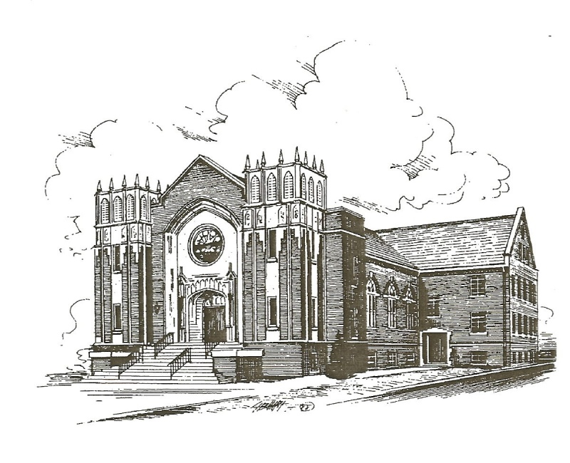

Dyer Cumberland Presbyterian Church
256 East College Street
P.O. Box 181
Dyer, TN 38330
Church: 731-692-2594
Church email: dyercpchurch@gmail.com
Website: dyercpchurch.wixsite.com/dyer

Pastor: Bro. Joey Edwards
901-573-7579

Dyer Cumberland Presbyterian Church


The Celebration of Worship
November 2, 2025 21st Sunday after Pentecost 11:00 AM
All Saints Day Observance

Ringing of the Bell

Welcome & Announcements

Altar Prayer

Prelude & Bringing Forth the Light

*Praise Song Count Your Blessings (v.1,2,4) p.563

*Call to Worship (Responsive Reading)
Leader: Here we stand watch for God's appearing.
Together we seek a presence of the work of the Holy Spirit.
Response: God is in this place and will give us understanding.
God sends visions of new possibilities.
Leader: God's righteousness is everlasting and God's law is truth.
We will listen to God's teachings and hear the Word of God.
Response: We seek to grow in faith and in love for one another.
We will follow God's guidance and heed to His call.

Hymn: We'll Understand It Better By and By (p.544)

Affirmation of Faith (In Unison) Apostles’ Creed
I believe in God, the Father Almighty, Maker of heaven and earth; and in Jesus Christ, His only Son our Lord; who was conceived by the Holy Spirit, born of the Virgin Mary, suffered under Pontius Pilate, was crucified, dead and buried; the third day He rose from the dead; He ascended into heaven, and sitteth at the right hand of God the Father Almighty; from thence he shall come to judge the quick and the dead. I believe in the Holy Spirit; the universal church; the communion of saints; the forgiveness of sins; the resurrection of the body, and the life everlasting. Amen

Youth Lord, I Need You by Matt Maher

Children’s Sermon April Martin
Special Music Praise Him! Praise Him!

Prayers of the People
Offertory
*Doxology and Offertory Prayer

*Scripture Reading 1 Corinthians 12:12-31 (NIV)

Message The Body of Christ

Sermon Notes

1. I____________2. P________3. E__________4. I____________

*Hymn of Invitation He Lives (v.1,2) p.220

*The Benediction Carrying Forth the Light

*The Choral Response Redeemed (v.1) p.519

(*) Please stand if you are able.

The Lord's Prayer
Our Father who art in Heaven
hallowed be Thy name.
Thy kingdom come, Thy will be done,
on earth as it is in Heaven.
Give us this day our daily bread
and forgive us our debts, as we forgive our debtors.
Lead us not into temptation, but deliver us from evil.
For thine is the kingdom, and the power,
and the glory, for ever and ever.
Amen.

