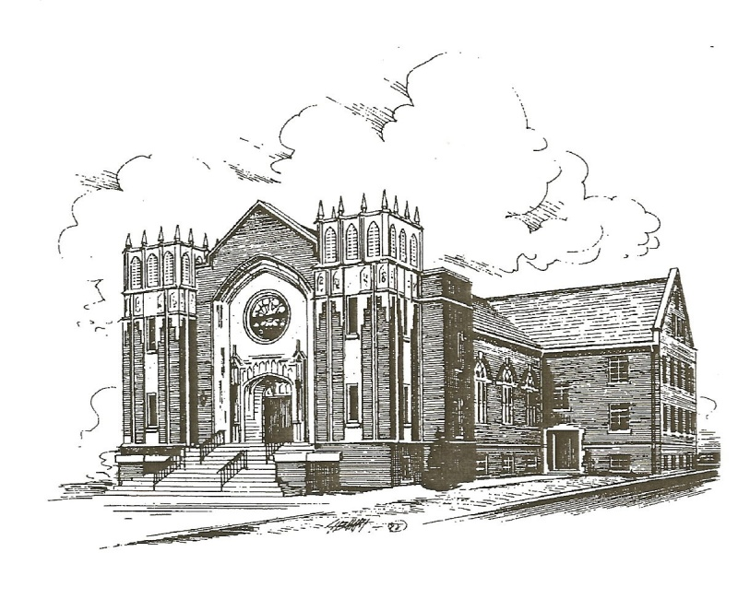

|  |  |
| --- | --- |
| **Today’s Events:** September 14, 2025  14th Sunday after Pentecost  Younger Youth Music 10-10:15  Sunday School at 10 am  Worship at 11 am.  **Upcoming Events**:  **Wednesday, September 17th**  **\*New time**-  6:00 pm Supper (ALL) (1st, 3rd, 5th meal provided; 2nd & 4th bring favorite potluck/add a dish meal)    6:30-7:30 pm Bible Study & activities    **Rides available on request**  **Upward Soccer practice**; Tuesday  & Thursday practices 6-7 pm (set  up 5:30)  **Wednesday, September 17th-** 55 Alive leaving at 10am for Brownsville to the Livingston Soda Fountain and Grill | **Saturday, September 20th** Upward  Soccer game; 9am & 10:15 am  **Sunday, October 26th**; End of  Soccer season celebration  *Please help us update the prayer  Concerns  ----------------------------------------------------------------------  Ministerial Alliance asks us to help provide instant potatoes for the holiday gift boxes. Our goal is 75 by Oct. 1st  September 7, 2025 Attendance 19  General Fund Offering $1,977.00  (General fund needed weekly-$3617.29)  Building Fund Offering 00.00 Bus Fund Offering 00.00 TOTAL $1,977.00 |

**Prayer Concerns**

Pray for Upward Soccer and People of Our Nation, Israel, Ukraine, Missionaries and our

World.

**Our Church Family at Home:** Mike Lewis, Ron Rogers, Bob & Becky McAlexander, Johnny McIlwain,Sarah Jane Owens, Richard Reed, JuneJones, Jim Sharp

**Assisted Living:** Lucy Bonds, Nell Taylor

**Other Prayer Concerns:** Dixie Smith, Abby Crandall, Ginger Emerson, Jane McCurdy, Brenda Croom, Kelly White, Dr. Mark Britton, Jennifer Davis, David Tidwell, Michael Morgan, Travis Landrum, Gene McReynolds, Glenn Long, Pam & Tommy Beasley, David Sewell, Jimmy Goad, Michael Bixler, Danny Gathings, Crissy Carter, Sherry Collins, Joyce Rollins, Emma Hilton, Bria Bills, Vicki Roberts, Sam Thompson, Deloires Copeland, Lisa Harper, James Carter, Patsy Whitaker, Lorrie Edwards, Joe Etheridge, Terrie Reevs, Belinda George, Rose Campbell, Janet Smith, Becky Cobb, JD Cowan, Brad Simmons, Paul Harrison, Carolyn Mathis, Kim Bone, Jennifer Huey, Richard Spry, Heather Capps, Natalie Reed, Melissa Ward Johnson, Chris Fisher, Tony Douglas, Sherry Bentley, Joe Presley, Shelly Connell, Leia Brewer, Carrie Hinson, Judy Baker, Tom Forsythe, John W. Davis, Christi Stanley, Lyla, Maddie & Cara Pereira, Evelyn Milam, Mae Beth Reed, Diane Blackard

**Condolences:**

*\*Please give names to be listed or updated to Michele on her desk in writing or via text or email (414-4065)* before *Thursday at 10:30; Office hours M-Th 8-12.* *The list will be updated at the end of each quarter.*

Dyer Cumberland Presbyterian Church

256 East College Street

P.O. Box 181

Dyer, TN 38330

Church: 731-692-2594

Church email: dyercpchurch@gmail.com

Website: dyercpchurch.wixsite.com/dyer

Pastor: Bro. Joey Edwards

901-573-7579

God, I confess I don’t always understand your ways. But like Peter, I say, “Lord, to whom shall we go? You have the words of eternal life” (John 6:68). Help me trust you more today.

Dyer Cumberland Presbyterian Church

**The Celebration of Worship**

September 14, 2025 14th Sunday after Pentecost 11:00 AM

**Ringing of the Bell**

**Welcome & Announcements**

**Altar Prayer**

**Prelude & Bringing Forth the Light**

**\*Praise Song** *Majesty* (p.74)

***\**Call to Worship** (Responsive Reading)

Leader:  God looks on mankind to see if any are wise.

               Who is seeking after God above all else?

**Response:   We look to Jesus for wisdom and truth.**

**We reach out to be strengthened for service.**

Leader:  Our God gives us tasks to do and strength to do them.

               God's Word of love is ours to proclaim.

**Response:    Teach us Your ways, O God.**

**Lead us on a level path.**

**Hymn:** *Tis So Sweet to Trust in Jesus* (v.1,2,4) p.350

**Affirmation of Faith** (In Unison)Apostles’ Creed

I believe in God, the Father Almighty, Maker of heaven and earth; and in Jesus Christ, His only Son our Lord; who was conceived by the Holy Spirit, born of the Virgin Mary, suffered under Pontius Pilate, was crucified, dead and buried; the third day He rose from the dead; He ascended into heaven, and sitteth at the right hand of God the Father Almighty; from thence he shall come to judge the quick and the dead. I believe in the Holy Spirit; the universal church; the communion of saints; the forgiveness of sins; the resurrection of the body, and the life everlasting.  Amen

**Youth Selection** *Yes, I Will* by Vertical Worship

**Children’s Sermon**

**Special Music**

**Prayers of the People**

**Offertory**

**\*Doxology and Offertory Prayer**

**\*Scripture Reading**  Romans 12:2 (NIV)

**Message** *The Will of God*

**Sermon Notes**

1. G_____________2. P____________3. P____________

**\*Hymn of Invitation***Wherever He Leads I'll Go* (v.1,2) p.367

**\*The Benediction** Carrying Forth the Light

**\*The Choral Response** *Higher Ground* (v.1) p.399

***(*) Please stand if you are able.***

**The Lord's Prayer**

**Our Father who art in Heaven**

**hallowed be Thy name.**

**Thy kingdom come, Thy will be done,**

**on earth as it is in Heaven.**

**Give us this day our daily bread**

**and forgive us our debts, as we forgive our debtors.**

**Lead us not into temptation, but deliver us from evil.**

**For thine is the kingdom, and the power,**

**and the glory, for ever and ever.**

**Amen.**