2025 PANORAMA SCHEDULE

Set-Up/Clean-Up

Scenes, Trees, Firewood & Lighting

Brandt Jercinovich, Marshall Moss, Gary Byrd

Outdoor Music

Leanne Edwards

Costumes

Angels & Wise Men
Leanne Edwards, Ashley Johnson
Shepherds
Mae Beth Reed, Janet Smith
Mary & Joseph
Sandy Moss, Kim Lee

Kitchen Crew

Jackie Taylor, Paula Langston, Charlotte Halford
* Set up of fellowship hall and food needs to be ready by 6:00 pm .

Outside Greeters

6:30 – 7:00 Beckie Jo Maxwell and Sherri Monsue
7:00 – 7:30 Amanda Williams Gail Jercinovich
7:30 – 8:00 Vanessa, Jeannie
8:00 – 8:30 Selena, Cheri

Scene 1 The Inn

6:30-7:00 Mary & Joseph
Olivia Williams and Conner Williams
Inn Keeper
Nate
7:00-7:30 Mary & Joseph
Joe and Pam Penn
Inn keeper
Seth
7:30-8:00 Mary & Joseph
Stacie, Jayson
Inn Keeper
Ace
8:00-8:30 Mary & Joseph
Chuck and Gaela
Inn Keeper
Will

Scene 2 The Stable

6:30-7:00 Mary & Joseph
Tyler, Katelyn
Wise Men
Carter, Will, Bro. Joey
Little Shepherd
Charlee
Angel
Kaylee
7:00-7:30 Mary & Joseph
John David and Michelle
Wise Men
Braden, Craig, ______________
Little Shepherds
Gage
Angel
Zoey
7:30-8:00 Mary & Joseph
Eric and Anndrea Dyer
Wise Men
Harrison Dyer, Reed Dyer, __________
Little Shepherds
Aiden
Angel
Madison Dyer
8:00-8:300 Mary & Joseph
April, Brian
Wise Men
Orren, Fletcher, Gunner
Little Shepherds
Gage
Angel
Aubree

Scene 3 Shepherds by the fire (Please add wood as necessary to keep fire going.)

6:30-7:00 Johnny Ward, Thalen, Jayden
7:00-7:30 Will, Gage, Gunner
7:30-8:00 Hudson, Cash, Andrew
8:00-8:30 Jackson, Shelton, Mary

Scene 4 Angels
6:30-7:00 Aubree, Lyla, Maddie
7:00-7:30 Olivia Johnson, Tori, Anastasia
7:30-8:00 Lyla, Maddie, Laney
8:00-8:30 Hannah, ___________, __________

2025 PANORAMA SCHEDULE

This event is our opportunity to share Christ with our community through the scenes to the scriptures and music to the laughter and conversations. If you know of someone who wants to participate, the more the merrier! And if you need to change your place within the schedule, that can be done! Above all be in prayer for this event, for those who will come through and for our church.

* Volunteers are welcome and needed! If you are listed but not able to participate, please notify Brandt or Gail Jercinovich. Brandt, 731-697-4673; Gail, 731-514-0167

*Most importantly, please remember this event is a representation of the Birth of Christ. Please be still and reverent while outside. We ask those walking the path outside speak quietly as well.

*Finger foods

As we do every year, we will need finger foods to serve our guests! All church members are encouraged to come and share in the fellowship for the entire time. Invite people and share the event on social media. This is our gift and witness to the community each Christmas! Be in prayer that we may be a blessing to someone this beautiful Advent Season.

Many Thanks,

The Special Events Committee

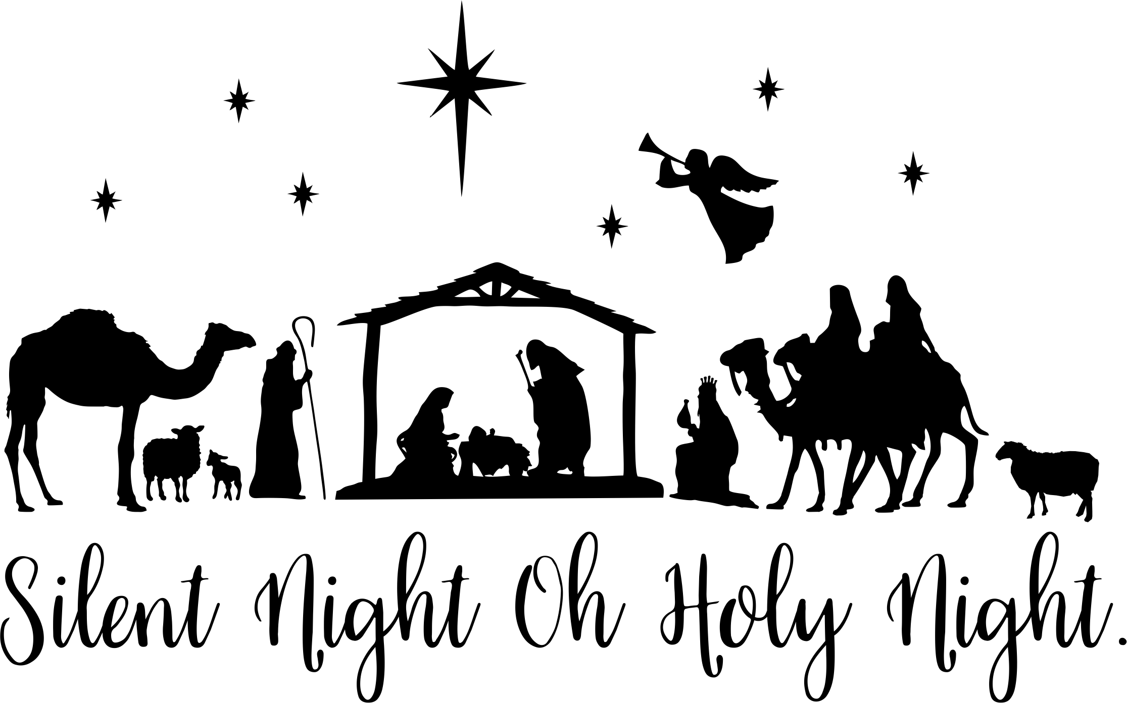

When Brandt and I started working on this year’s Nativity schedule, I asked how long the church had been doing it. We found the answer…53 years! Wow! This has become one of the traditions that make our Christmas as individuals and as a church family. When I mentioned the event to some of the children, they were SO excited! (Think…eyes lit up…smiling ear to ear…) They immediately asked if they could be angels! We hope you are as excited as those children when we get together as a church family, presenting a 53-year-old tradition of proclaiming our Savior’s birth.
Thanks to everyone who offered to help! If you need to change the schedule, just let us know. There are a few open spots that we may be able to fill with someone already in costume. However, if you know of someone who wants to help, please let us know.

